Case Study 1: Create an E-Commerce Website Billing Calculator

Aim
To design and develop an e-commerce website billing calculator using JavaScript that allows users to select products, calculate the total bill, apply GST, and display the final payable amount dynamically.

Software/Tools Required
• Visual Studio Code
• Web Browser (Google Chrome / Microsoft Edge / Mozilla Firefox)
• HTML5
• CSS3
• JavaScript

Code
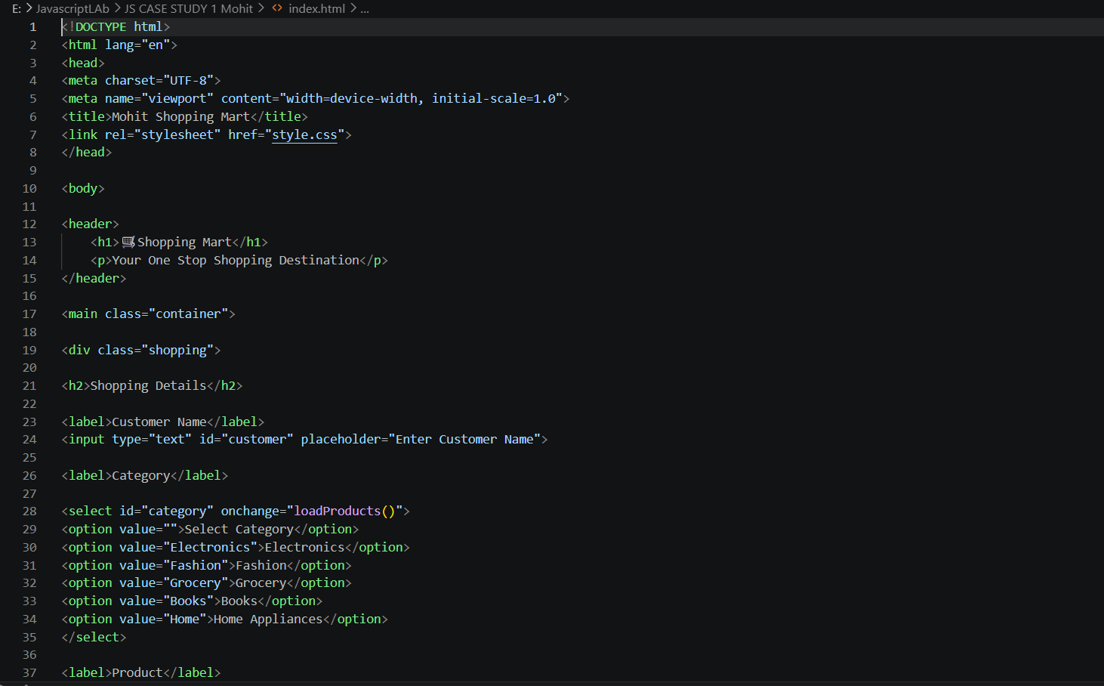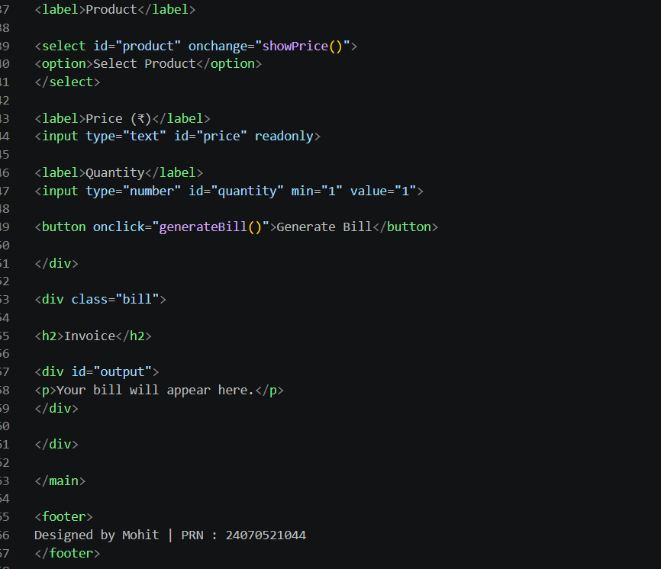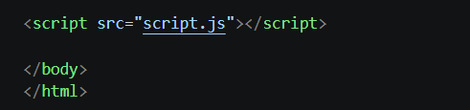

Output Screenshot

